**ASP.NET MVC TaskS**

Note: Create new folder “ASP.NET_MVC_tasks” contains 31.01.2023 file in your repo with the bellow:

1. Create controller with name Default with the following actions:

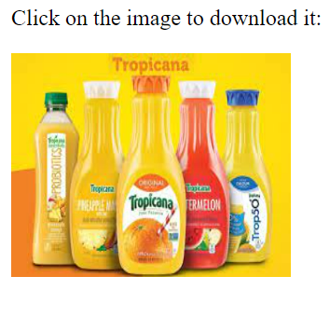

* 1. About us action
  2. Contact Us

**2- Create Controller with your name with at least different 4 actions**